**REFACTORING LIST**

Team 11

By compare between the implementation of the build 2 and the requirement of build 3, We listed following refactoring list:

1. Display the dice info when a player is attacking

|  |  |
| --- | --- |
| Build 2 | Dice info is in the black box, player cannot see. |
| Build 3 | required to display the dice info. |
| Decision | Required |
| Solution | Out put the dice info in the console. |

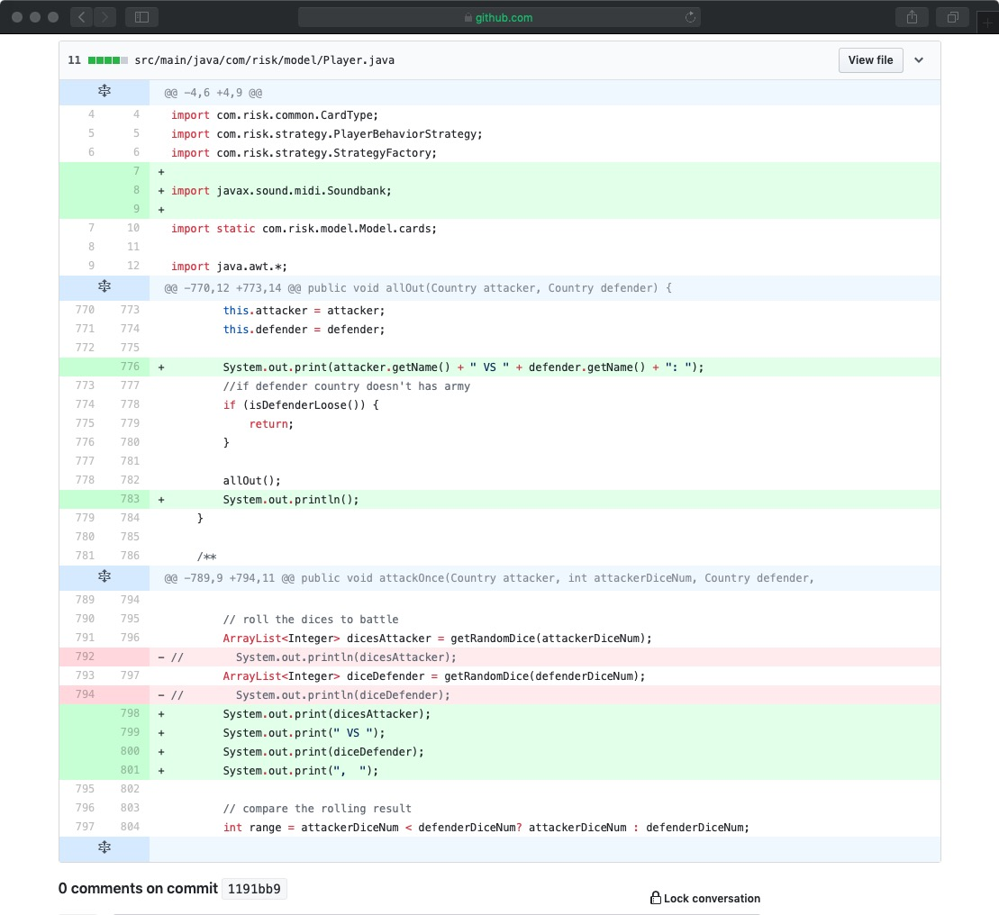

1. Create the strategy pattern, move the methods reinforcement(), attack(), moveArmy(), and fortification(), four method to the ManualStrategy class.

|  |  |
| --- | --- |
| Build 2 | Methods reinforcement(), attack(), moveArmy(), and fortification() are in player class. |
| Build 3 | Implementation of different player behaviors using the Strategy pattern |
| Decision | Required |
| Solution | 1. Create the strategy interface: PlayerBehaviorStrategy; 2. Create HumanStrategy class implements PlayerBehaviorStrategy, and move reinforcement(), attack(), moveArmy(), and fortification() methods to HumanStrategy class. |

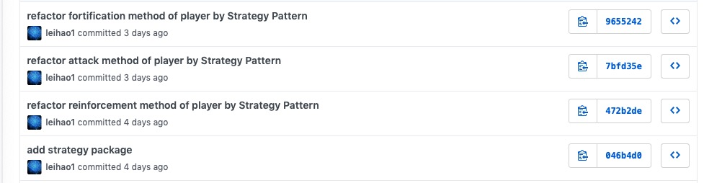

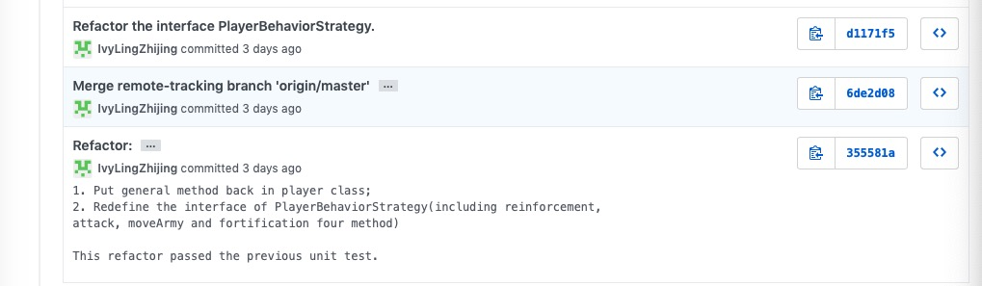

1. Singleton instance as a class variable

|  |  |
| --- | --- |
| Build 2 | Some class create a class variable when it’s a singleton instence |
| Build 3 | -- |
| Decision | Required, it will occur some error when reload the game |
| Solution | Use getInstence() to get the unique instance of singleton |

